EX.NO:02 | PERSONAL FINANCIAL TRACKER SYSTEM
DATE:

1.AIM:
To develop an Personal Financial Tracker System using HTML, CSS, and JavaScript that allows users to record income and expenses, calculate balance and savings, visualize financial data using charts, and export transaction data as a CSV file.
2.PROCEDURE:
Step 1: Create the webpage structure using HTML with dashboard cards, transaction form, charts, and table.
Step 2: Design the interface using CSS for layout, colors, and responsive dashboard display.
Step 3: Integrate Chart.js to display financial data using bar and pie charts.
Step 4: Implement JavaScript to add transactions, calculate income, expense, and balance.
Step 5 : Store and retrieve transaction data using localStorage.
Step 6 : Display transactions in a table and update charts dynamically.
Step 7 : Export transaction data as a CSV file.

3.PROGRAM SOURCE CODE:
Finance.hhtml
<!DOCTYPE html>
<html lang="en">
<head>
<meta charset="UTF-8">
<title>Advanced Personal Finance Tracker</title>
<script src="https://cdn.jsdelivr.net/npm/chart.js"></script>

<style>
body{
font-family:Segoe UI;
background:#eef2f7;
margin:0;
}
header{
background:#1e3a8a;
color:white;
padding:15px;
text-align:center;
}

.container{
width:95%;
margin:auto;
}

.dashboard{
display:flex;
gap:20px;
margin-top:20px;
flex-wrap:wrap;
}

.card{
flex:1;
background:white;
padding:20px;
border-radius:10px;
box-shadow:0 4px 8px rgba(0,0,0,0.1);
text-align:center;
font-size:18px;
}

.income{border-left:6px solid green;}
.expense{border-left:6px solid red;}
.balance{border-left:6px solid blue;}
.savings{border-left:6px solid orange;}

form{
background:white;
padding:15px;
margin-top:20px;
border-radius:10px;
box-shadow:0 4px 8px rgba(0,0,0,0.1);
}

input,select,button{
padding:10px;
margin:5px;
font-size:16px;
}

button{
background:#1e3a8a;
color:white;
border:none;
cursor:pointer;
}

button:hover{
background:#2563eb;
}

.chart-container{
display:flex;
flex-wrap:wrap;
gap:20px;
margin-top:20px;
}

canvas{
background:white;
padding:10px;
border-radius:10px;
box-shadow:0 4px 8px rgba(0,0,0,0.1);
}

table{
width:100%;
margin-top:20px;
background:white;
border-collapse:collapse;
}

th,td{
padding:10px;
border:1px solid #ccc;
text-align:center;
}

th{
background:#1e3a8a;
color:white;
}
</style>
</head>
<body>
<header>
<h2>Advanced Personal Finance Tracker Dashboard</h2>
</header>

<div class="container">
<!-- Dashboard -->

<div class="dashboard">

<div class="card income">
Income: ₹<span id="income">0</span>
</div>
<div class="card expense">
Expenses: ₹<span id="expense">0</span>
</div>
<div class="card balance">
Balance: ₹<span id="balance">0</span>
</div>
<div class="card savings">
Savings: ₹<span id="savings">0</span>
</div>
</div>
<!-- Form -->
<form onsubmit="addTransaction(event)">

<select id="type">
<option value="income">Income</option>
<option value="expense">Expense</option>
</select>

<input type="number" id="amount" required placeholder="Enter amount">
<input type="month" id="month" required>
<button type="submit">Add Transaction</button>
<button type="button" onclick="exportCSV()">Export CSV</button>
</form>

<!-- Charts -->

<div class="chart-container">
<canvas id="barChart" width="400" height="300"></canvas>
<canvas id="pieChart" width="400" height="300"></canvas>
</div>
<!-- Table -->
<table>
<thead>
<tr>
<th>Type</th>
<th>Amount</th>
<th>Month</th>
</tr>
</thead>
<tbody id="tableBody"></tbody>
</table>
</div>
<script>
let transactions = JSON.parse(localStorage.getItem("transactions")) || [];
let totalIncome = 0;
let totalExpense = 0;
const barChart = new Chart(document.getElementById("barChart"), {

type:'bar',

data:{
labels:["Income","Expense","Balance"],
datasets:[{
label:"Finance Summary",
data:[0,0,0]
}]
}
});

const pieChart = new Chart(document.getElementById("pieChart"), {
type:'pie',
data:{
labels:["Income","Expense"],
datasets:[{
data:[0,0]
}]
}
});
function addTransaction(e)
{
e.preventDefault();

let type=document.getElementById("type").value;
let amount=parseFloat(document.getElementById("amount").value);
let month=document.getElementById("month").value;
let transaction={type,amount,month};

transactions.push(transaction);
localStorage.setItem("transactions",JSON.stringify(transactions));

if(type=="income")
alert("Income Added Successfully!");
else
alert("Expense Added Successfully!");
updateAll();
}

function updateAll()
{
totalIncome=0;
totalExpense=0;
let table="";
transactions.forEach(t=>{

if(t.type=="income")
totalIncome+=t.amount;
else
totalExpense+=t.amount;
table+=`<tr>
<td>${t.type}</td>
<td>${t.amount}</td>
<td>${t.month}</td>
</tr>`;
});
document.getElementById("tableBody").innerHTML=table;
let balance=totalIncome-totalExpense;

document.getElementById("income").innerText=totalIncome;
document.getElementById("expense").innerText=totalExpense;
document.getElementById("balance").innerText=balance;
document.getElementById("savings").innerText=balance;
updateCharts(balance);
}
function updateCharts(balance)
{
barChart.data.datasets[0].data=[totalIncome,totalExpense,balance];
barChart.update();
pieChart.data.datasets[0].data=[totalIncome,totalExpense];
pieChart.update();
}
function exportCSV()
{
let csv="Type,Amount,Month\n";
transactions.forEach(t=>{
csv+=`${t.type},${t.amount},${t.month}\n`;
});
let blob=new Blob([csv],{type:"text/csv"});
let url=window.URL.createObjectURL(blob);

let a=document.createElement("a");
a.href=url;
a.download="finance_data.csv";
a.click();
}
updateAll();
</script>
</body>
</html>
4.SAMPLE INPUT/ OUTPUT:
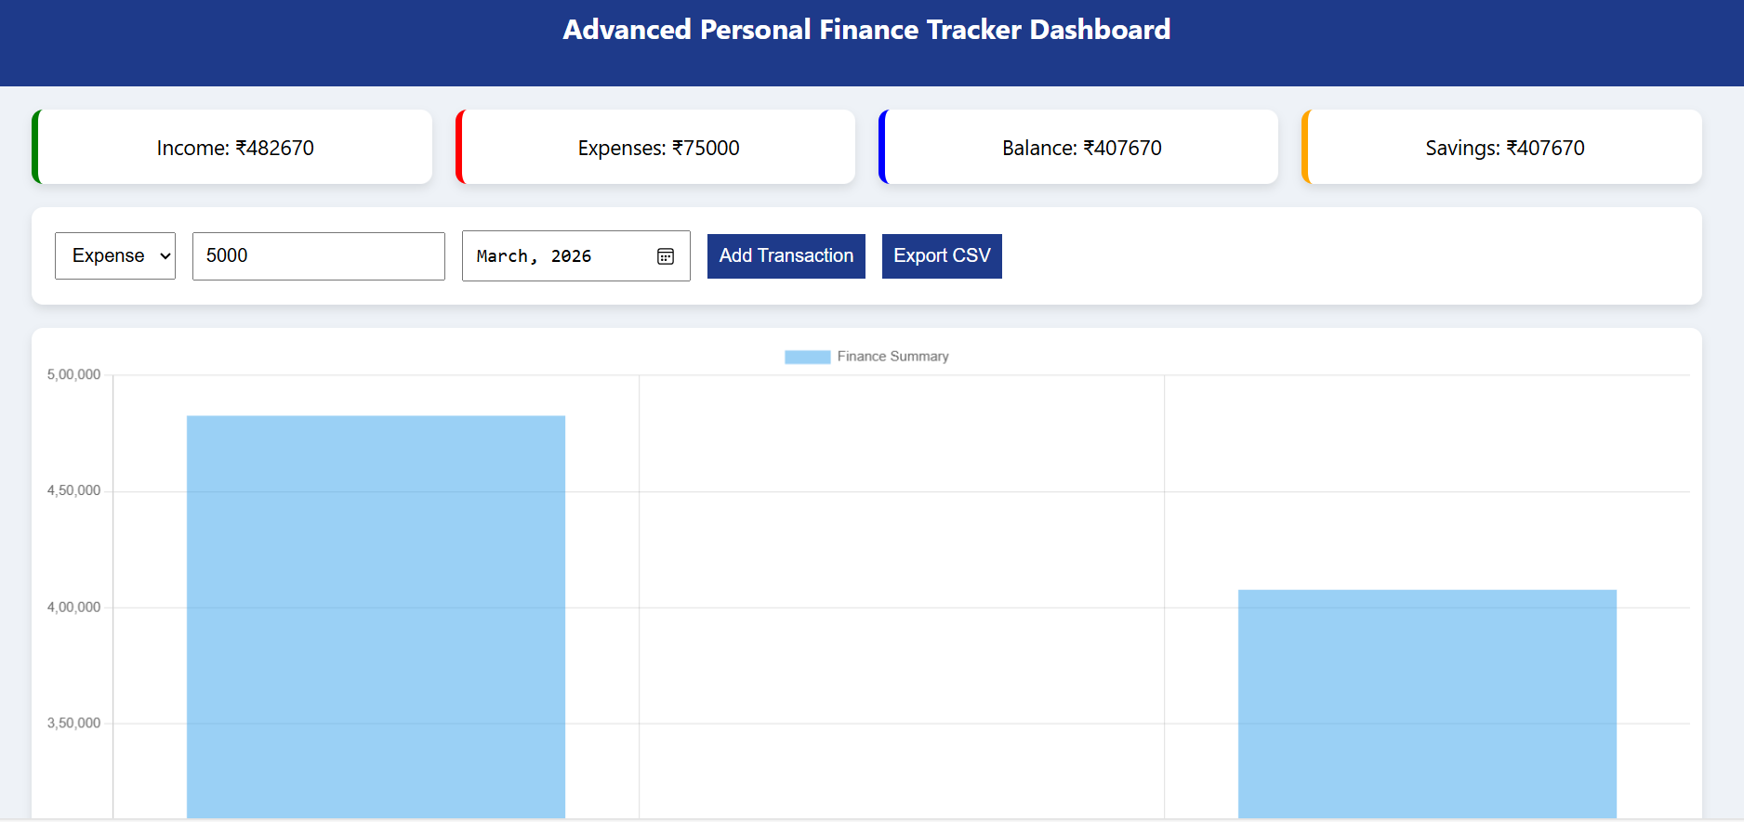

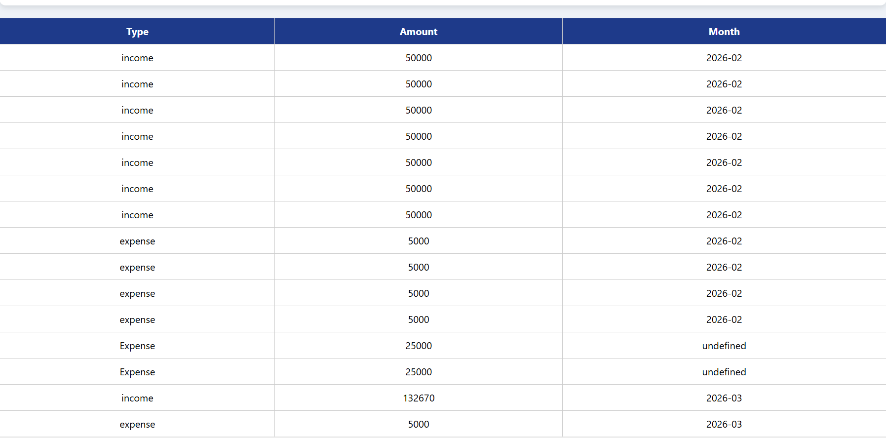

5.RESULT:
Thus, the Personal Financial Tracker System was successfully implemented to manage income and expenses, calculate balance, and visualize financial data.

